- Create a comparison table listing the main differences between DDR3, DDR4, and DDR5 RAM, including speed, voltage, and typical use cases.

Type | Speed | Voltage | Common Use
DDR3 | 800–2133 MT/s | 1.5V | Older PCs
DDR4 | 2133–5333 MT/s | 1.2V | Most modern PCs
DDR5 | 4800+ MT/s | 1.1V | Latest high-performance systems

- Open your laptop or desktop (with power disconnected), locate the RAM slots, and take a clear photo of the installed RAM module. Reinstall the RAM module and verify that your system boots up successfully.<br><br><em><strong>Hint:</strong> Refer to your device manual or a trusted YouTube guide if unsure about RAM removal and installation steps.</em>
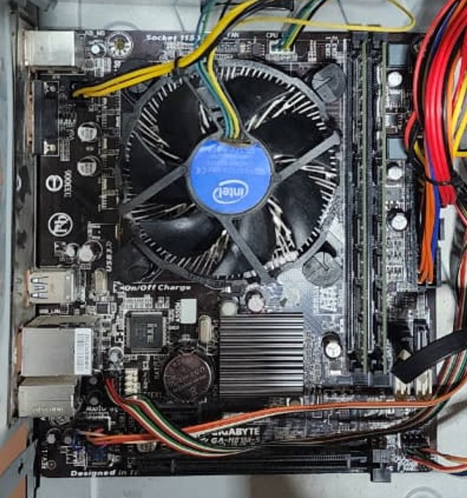
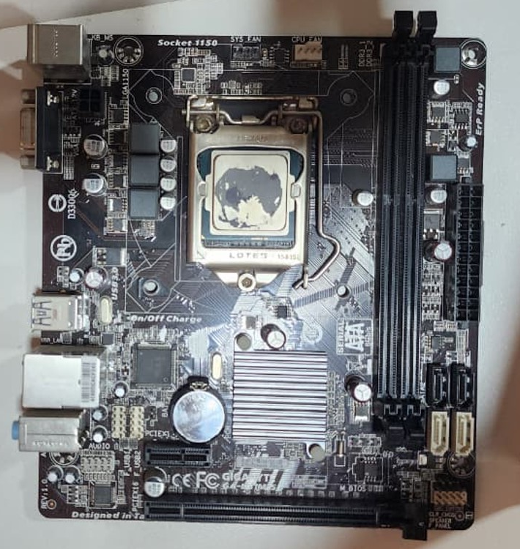
RAM installed
RAM reinstalled

- List three key differences between HDD, SSD, and NVMe storage types, and for each, name one app or use case (from apps you use daily) that would benefit most from that storage type.
Feature | HDD | SATA SSD | NVMe SSD
Interface | SATA | SATA | PCIe
Typical Speed | 80 to 160 MB/s | Up to 550 MB/s | 2000–14000+ MB/s
Connector | SATA cable | SATA cable | M.2 slot
Technology | Uses spinning magnetic platters | zero moving parts | zero moving parts
Advantages | Large storage capacity | Faster file transfers | Faster file transfers
Characteristics | Lowest cost per gigabyte | Higher cost per GB than HDDs | Higher cost per GB than HDDs
Performance | Good | Very Good | Excellent
Used | Archival Storage | Daily OS & Applications | System + gaming + Intensive Tasks

- Remove the storage drive (HDD or SSD) from your system, take a photo of the connector type (SATA, M.2, or NVMe), and reinstall the drive. Confirm that your device recognizes the storage after reassembly.<br><br><em><strong>Constraint:</strong> Only perform this task if you have access to a device you are allowed to open. If not, find and share a YouTube video link showing the process for your laptop/PC model.</em>
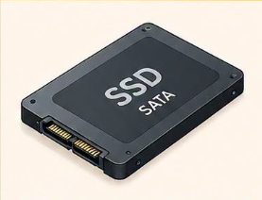
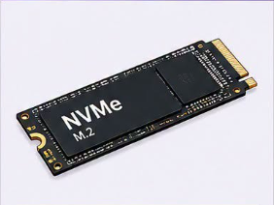
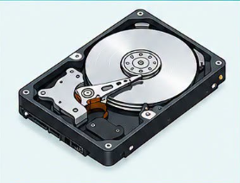
HDD
SSD
NVMe

- Photos of the computer I did my practical on.
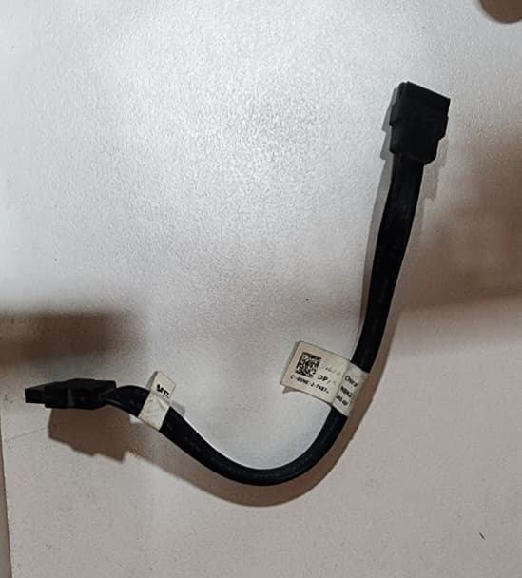
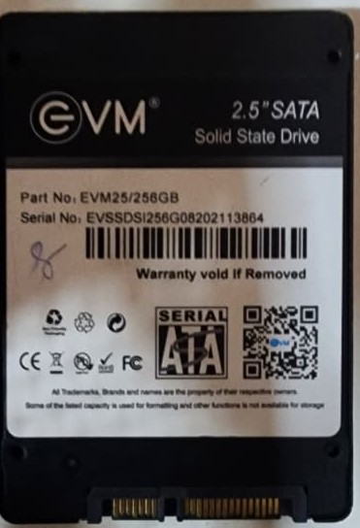
SDD
Sate cable
SSD is connected here using a SATA cable.
